Requirements
- MetaMask installed
- Sepolia network enabled
- Sepolia ETH in Account 1 (deployer) and ideally Account 2 (receiver)
- Remix IDE: remix.ethereum.org
- Your ERC1155 contract code

Part A — MetaMask Sepolia Setup
- MetaMask → enable Test Networks
- Select Sepolia
- Get Sepolia ETH from a faucet
- Make sure you have enough for deployment + transactions
Checkpoint: You have Sepolia ETH in Account 1
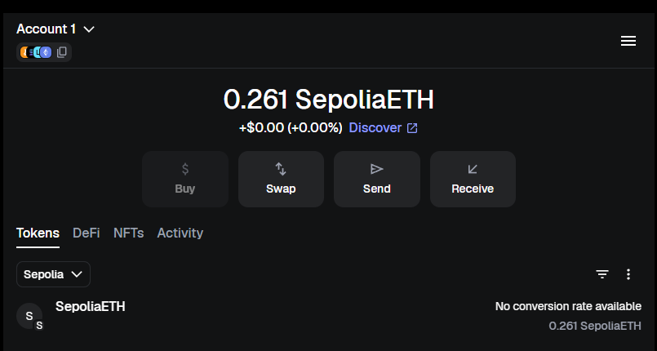

Part B — Remix Setup
- Open Remix
- Create file: MyMultiToken.sol
- Paste your ERC-1155 contract code
Checkpoint: file saved in Remix
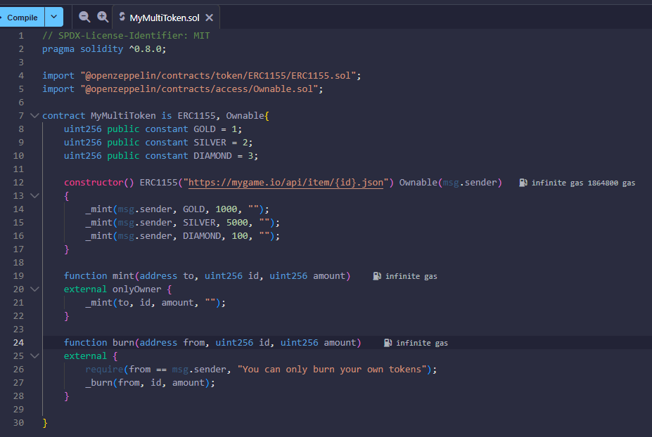

Part C — Fix OpenZeppelin Imports (if needed)
- Go to Solidity Compiler → Compile once
- If imports fail:
  - Add OpenZeppelin contracts using Remix Dependencies / Packages
Checkpoint: no import errors
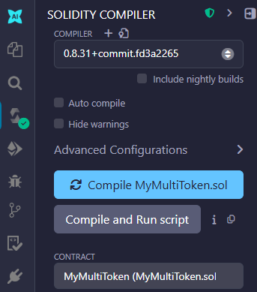

Part D — Compile
- Compiler version: 0.8.x compatible with ^0.8.0
- Click Compile
Checkpoint: compilation success
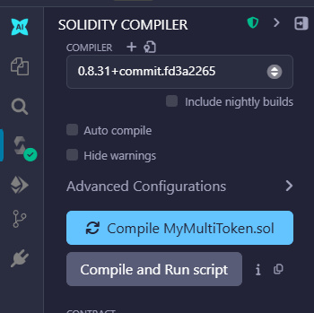

Part E — Connect Remix to MetaMask (Sepolia)
- Deploy & Run Transactions tab
- Environment: Injected Provider (MetaMask)
- Approve MetaMask connection
- Confirm network is Sepolia
Checkpoint: Remix shows your MetaMask account
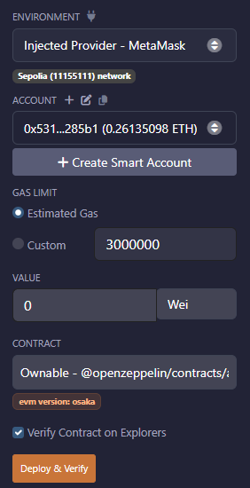

Part F — Deploy Contract
- Select contract: MyMultiToken
- Click Deploy
- Confirm in MetaMask
Checkpoint: contract appears under Deployed Contracts
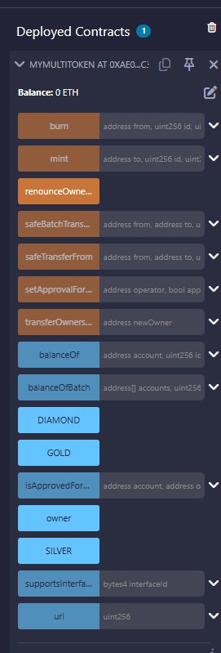

Part G — Read & Verify Initial Supplies
Test G1: Check initial balances (Account 1)
In the deployed contract UI, call:
- balanceOf(account1, 1) → should be 1000
- balanceOf(account1, 2) → should be 5000
- balanceOf(account1, 3) → should be 100
Checkpoint: balances match the constructor mints
If your UI shows a balanceOf function:
Enter:
- account: your address
- id: 1, 2, or 3
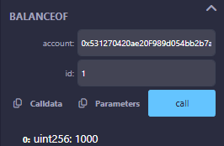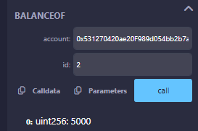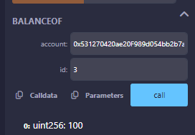

Part H — Test Owner-only Mint
Test H1: Mint GOLD to Account 2 (owner action)
- Switch nothing (stay in Account 1 owner)
- Call: mint(to=Account2, id=1, amount=50)
- Confirm transaction
Then verify:
- balanceOf(Account2, 1) → 50
- balanceOf(Account1, 1) → still 1000 (because mint creates new tokens)
Checkpoint: Account 2 received minted GOLD
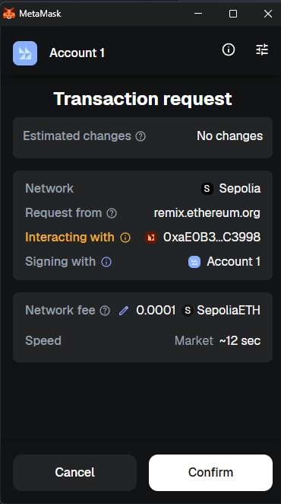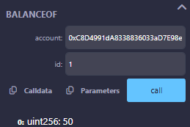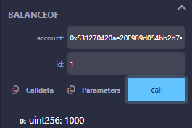

Test H2: Non-owner tries to mint (should FAIL)
- Switch MetaMask to Account 2
- In Remix, still Injected Provider (it follows MetaMask active account)
- Call: mint(to=Account2, id=2, amount=10)
Expected: Transaction reverts (fails) due to onlyOwner
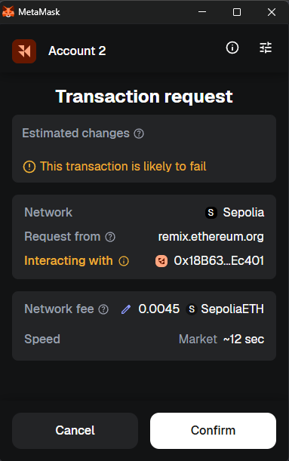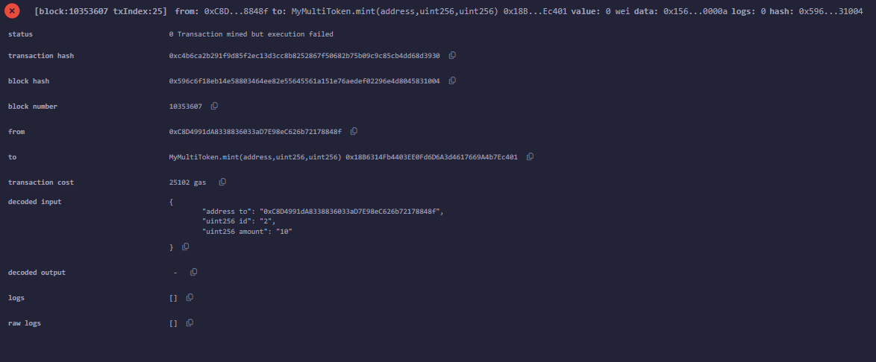

Part I — Burn Tests (Self-only)
Test I1: Burn your own tokens (Account 2)
- Keep MetaMask on Account 2
- Call: burn(from=Account2, id=1, amount=10)
- Confirm transaction
Verify: balanceOf(Account2, 1) decreased from 50 → 40
Checkpoint: burn works for your own balance
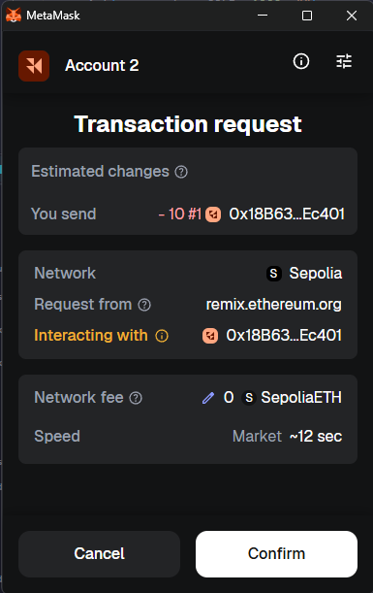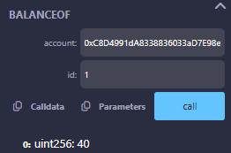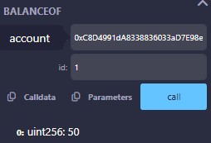

Test I2: Attempt to burn someone else’s tokens (should FAIL)
Still in Account 2:
- call burn(from=Account1, id=1, amount=1)
Expected: Revert with:
- "You can only burn your own tokens"
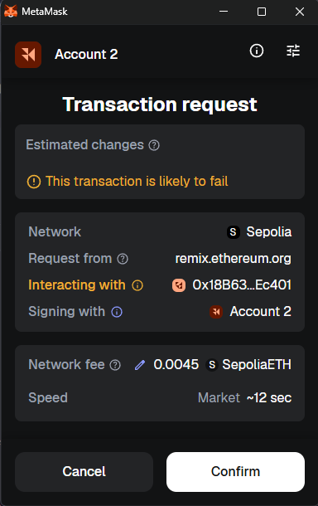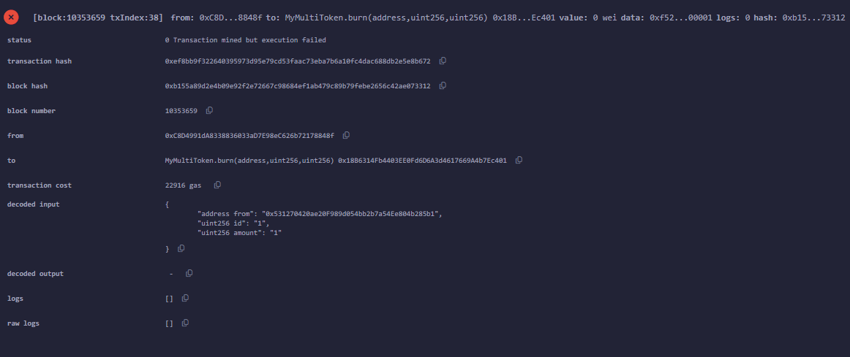

Part J — Transfer Tests (ERC-1155 Safe Transfer)
Test J1: Transfer GOLD from Account 1 to Account 2
- Switch MetaMask back to Account 1
- Use: safeTransferFrom(from=Account1, to=Account2, id=1, amount=25, data=0x)
- Confirm transaction
Verify:
- balanceOf(Account2, 1) increases by 25
- balanceOf(Account1, 1) decreases by 25
Checkpoint: ERC1155 transfer works
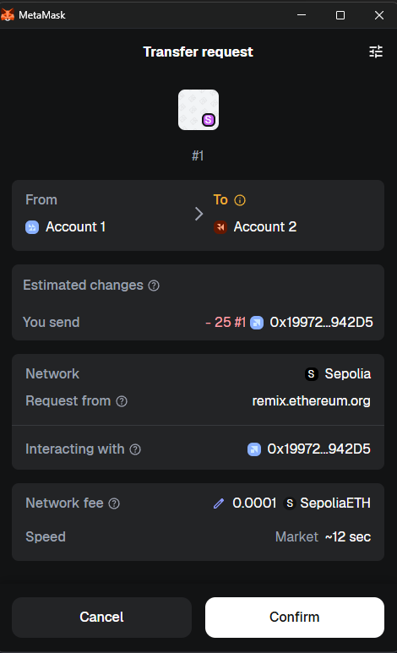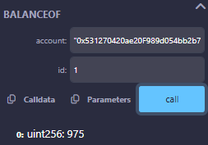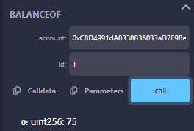

Part K — Approval Tests (Operator Approval)
ERC-1155 supports “operators” who can transfer on your behalf:
- setApprovalForAll(operator, approved)
- isApprovedForAll(owner, operator)
Test K1: Approve Account 2 as operator for Account 1
- MetaMask: Account 1
- Call:
  - setApprovalForAll(Account2, true)
- Verify:
  - isApprovedForAll(Account1, Account2) → true
Checkpoint: operator approval enabled
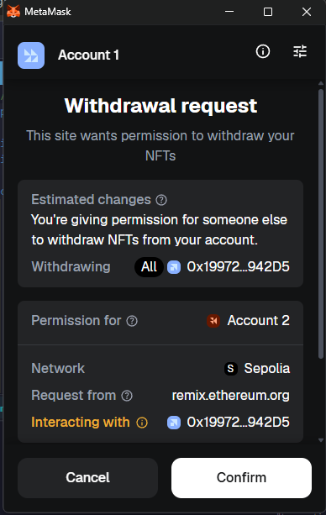
Test K2: Transfer from Account 1 using Account 2 as operator
- Switch MetaMask to Account 2
- Call:
  - safeTransferFrom(from=Account1, to=Account2, id=2, amount=100, data=0x)
Expected: should succeed only if approval is true
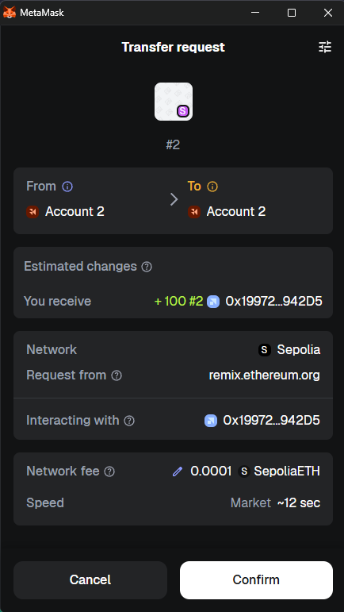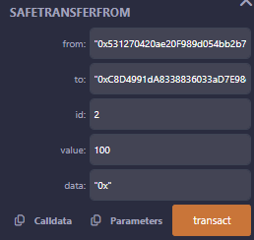
Account 1 on from: "0x531270420ae20F989d054bb2b7a54Ee804b285b1"
Misleading on metamask popup

4) Common gotchas (ERC-1155 specific)
- URI doesn’t open: your URI is a sample domain; it won’t resolve unless you host metadata.
- {id} formatting: ERC-1155 expects {id} as 64-hex padded by many implementations; OpenZeppelin follows the standard substitution behavior.
- Burn restriction: your burn requires from == msg.sender — operators cannot burn on behalf (unless you change logic).
- Transfers require data bytes: in Remix, use 0x or 0x00… as needed.

5) Post-lab questions (ERC-1155 version)
- What are the token IDs for GOLD, SILVER, DIAMOND?
GOLD = 1
SILVER = 2
DIAMOND = 3
- Why can Account 2 not call mint()?
mint() function is restricted with onlyOwner which is Account 1
- What function confirms how many tokens of an ID a wallet owns?
balanceOf
- Why does burn(Account1, id, amount) fail when called by Account 2?
Account 2 cannot burn tokens from Account 1 because msg.sender != from.
- What is the difference between _mint() and safeTransferFrom()?
_mint creates new token while safeTransferFrom() transfers already existing token

